s.no |  | Issue | Attachment
1 | When opening the app for the first time, the updating data please wait is being processed.The Updating data process is getting killed only after the app terminates. It is not returning or process even after pressing back button. |  | Refer video no  Record_2024-08-22-12-04-36.mp4
2 | Data is not being uploaded even after waiting a lot. |  | 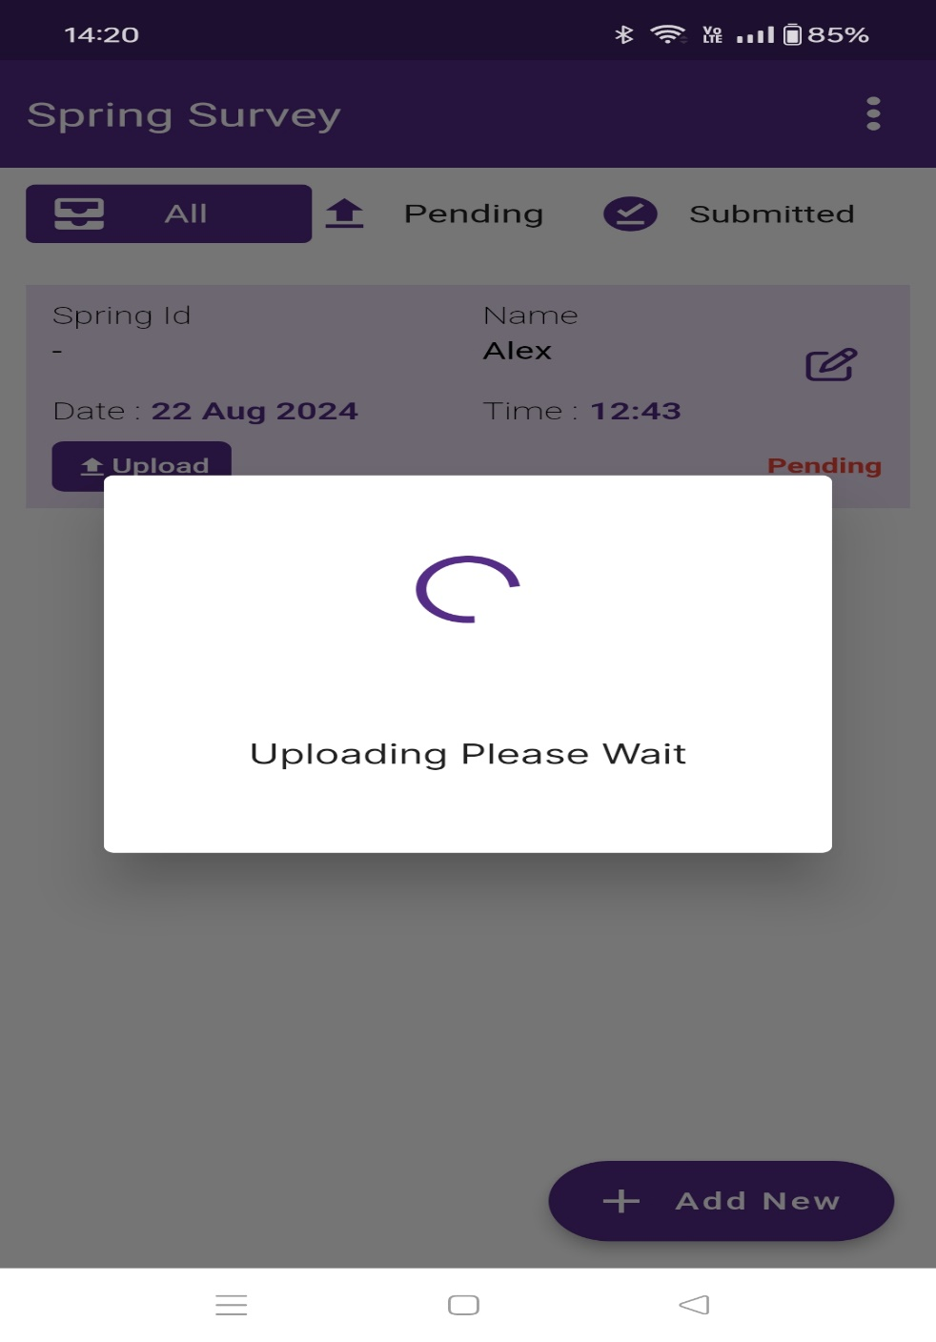
3. | After installing the app and filled all details of survey, pending schedule is shown but after uninstalling app, pending schedule is not shown. |  | 