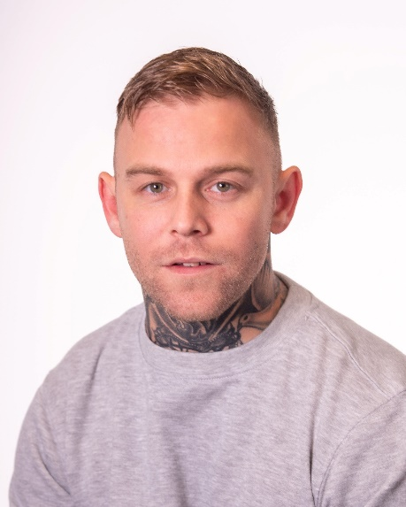
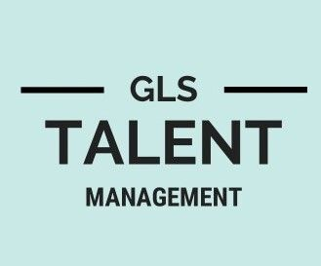
3 Newlands Road
Southgate, Crawley
West Sussex, RH11 8AL 07780531881 gemma@glstalentmanagement.com www.glstalentmanagement.com

Wayne Dobson
Location  Height  Weight  Playing age  Ethnicity | Middlesbrough  171 cm  71.67 kg  27/35  White | Eye colour  Hair colour  Hair length | Green  Light/Mid Brown  Short

Film

2022, Callum (Lead), Wiccan, Lumar Films, Martin Handsley
2022, Tony, Night Girlz, Champ Dog Films, Jasmine Ebony Thomas
2022, Conrad, The Lynemouth Werewolf, Ben Eccles

Television

2022, Prisoner, Happy Valley Season 3, Red Production Company, Fergus O'Brien
2022, Tony (one of the leads), Snatching Sanity, KC Entertainment Productions

Short Film

2022, Steven (Lead), The Envelope, London University, Marianne Sill art
2022, Hennessy (Lead), Family Ties, Salford University, Gracie Nuttall
2022, Band Player, The Perfect Night, Stephane Alexandre
2022, Rob, Pilot, Giles Pengelly
2022, Bart, The Perfect Man, Dumb Blonde Productions, Alyse McCamish
2022, Joe (Lead), Not The Finest Hour, Manchester University, Dimitri Michael’s

Accents | Cockney, Durham, Geordie, Middlesbrough, Sunderland, Teesside,
Sports | Air Rifle Shooting, Boxing, Jet Ski, Karting, Kick Boxing, Martial Arts, Motocross, Muay Thai, Quad Biking,  Thai Boxing, stage combat, weapons training
Licences | Car Driving Licence
Other skills  (* = highly skilled) | Angle Grinding, Bartender, Bricklayer (experienced), Construction (experienced), DBS (CRB) clearance, Handgun Handling
Training | Act up north tv and film acting

The information in this CV may have been provided by partner sites. Every effort has been made to make sure that the information contained on this page is correct and Tagmin can accept no responsibility for its accuracy.
Wayne Dobson 1/1

