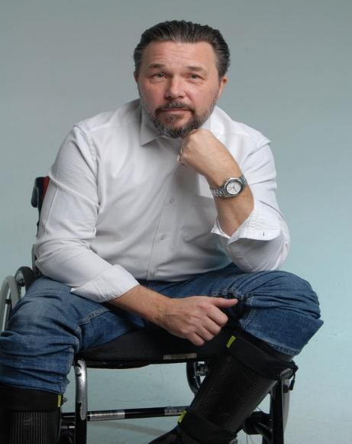
4545
D.O.B: 19/07/1974 playing Age from 40 – 60
Address: 9 Farrington Avenue Bushey, Hertfordshire, wd23 3dg
Contact number: 07982902904
Email: martbarry27@gmail.com

MART BARRY
Attributes: Wheelchair user
Height:5ft 9
Waist measurement:35 inches
Hip measurement:
Inside leg measurement:32 inches
Head circumference:

PERSONAL PROFILE:
Being a late starter to Acting, I have hit the ground running and had a busy 2025 with 2026 starting in the same vein, receiving one to one tuition and coaching from class act with Fab Santino. I have my first lead role in a Graduation film for UCA (REPLIKA) filming in Feb 2026 and a supporting role in March (Maggies Lament) . Also in Spring I will be filming a short film opposite Alan Emerys , so far I have shown how versatile I can be, playing roles as a non disabled characters. I have a wealth of experience to draw from including the Armed forces and sports coaching.

SOCIALS:
Instagram: mart.barry
Facebook: mart.barry

PERFORMANCE EXPERIENCE
- “The Force” the Micheal Watson story Directed by Sean Cronin,playing role of Boxing Commentator in the Eubank v Watson fight (in production) Scripted Role.
- Tottenham hotspur & sponsor Kraken advert with Thomas Frank, played a Journalist asking Thomas Frank a question Scripted and featured Role.
- Graduation Film “The Pull” Protestant tug of war supporter Director: Jack Loyd (in production) London Film School Featured Role.
- “Pour me” starring Shaun Thomas Directed by Jesse Reece Lewis. Played pub local (2025).
- “Stuck” Winchester university short film playing role of Dad Scripted Role.
- Advert for the home office “Violence against women and girls” wheelchair user in supermarket (2025).
- Rap Music video “Ghantra” Buisiness man (2025).
- “Home” for the Straight 8 competition 2026 playing the role of a Dad with a terminal illness. Directed by Jai Sarvesh
- Service Now AI Commercial with Idris Elba as the hero role of office worker 2026
- Grand tour :trailer wheelchair user in cafe of Grand tour tent 2025.
- Rap Video Khan Brian (2.4 million instagram followers) wheel chair basket ball player Featured role.
- Commercial modelling for Sysco stills by photographer Igor Emmerich Glass house studios Folkeston Kent
- Slow Horses playing hub agent 6 episodes season 7 Directed by Rob Mkerrick 2026
- Brighton hove Albion Bus service CPC training video directed by Tony Burke shoot to kill films,playing role of wheelchair user.2026
- REPLIKA - short film playing Arthur Teale lead role- 2026 directed by Sam Acoras
- MAGGIES LAMENT - short film playing Sammie- 2026 directed by Cloud Jones

