**ANGELA WILDING**

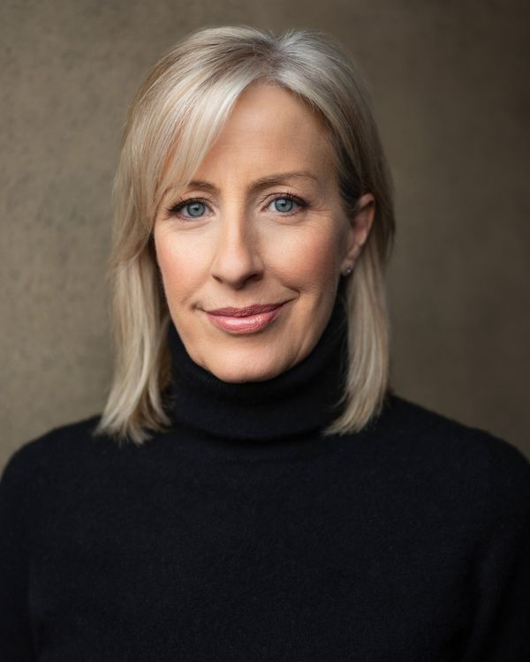

Telephone: +44 7931 685170  
Email: angelawilding3@outlook.com

Location: Cambridge, London & Bristol

Playing Age: 50-60

Height: 5’6”

Hair Colour: Blonde

Hair Length: Medium/Long

Eye colour: Blue

**Training**

London Actors Workshop Acting for Film & TV

RADA - Voice, Movement, Contemporary Text, Classical Text

London Studio Centre Diploma in Performing Arts

The Open University – BA (Hons) in Humanities with Art History

**Credits**

Film 2024: 'Table For Two' Role Julia Armstrong D82 Productions Director Luke Thomas

Film 2024: 'Mountain Shark' Role Major Jennifer Hawkes ChampDog Films Director Greg Keith

Film School 2024: 'Everything is OK' Role Bar Manager University of Salford Director Dylan Stones

Film School 2023: 'Umbilical Cord' Role Lorraine London Film School Director Zoe Hao

Television 2024: 'Wimbledon' Role Martina Navratilova Glass Onion Films Director Carl Addy

Television 2000: 'Star For A Night' BBC Television Director Geraldine Dowd

Musical 1996: 'A Chorus Line' Role Val Triple Threat Theatre Company Director Darren Purdey

Musical 1986 'Starlight Express' Role Swing Really Useful Theatre Company Director Trevor Nunn

**Skills***(*highly skilled/native)*

**Languages**: English* (native)

**Accents**: American (Standard/Southern/New York), French, Scottish, Northern, Russian, Irish **Performance**: Actor, Radio Presenter **Singing**: Mezzo Soprano

**Dance**: Ballet, Contemporary, Jazz, Tap

**Sports**: Skiing*, Roller skating*, Cycling*  
**Other:** Driving licence

**Training**

London Actors Workshop Acting for Film & TV

RADA - Voice, Movement, Contemporary Text, Classical Text

London Studio Centre Diploma in Performing Arts

The Open University – BA (Hons) in Humanities with Art History