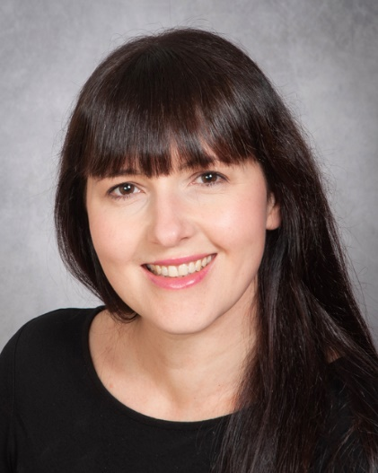**Elle E   
07722 552152  
elle@elleemodel.com**

**Spotlight PIN – 3333-5616-0673  
Spotlight Link -** <https://www.spotlight.com/3333-5616-0673> **Playing Age: 28-38  
Height: 158cm  
Appearance: White British  
Location: Midlands and London**

**ACTING ROLES  
  
Year Production Role Company Production Company/**

**Director**

* **Television**

2024 The Poisoning – How To Tracey Hardwick (daughter) Channel 5 ITN Productions/Craig  
Kill Your Husband (True Chambers  
Crime Documentary)

* **Film**

**Shorts**  
2025 Fungus Mona (Lead) Our Little Ayesha Walker (Director)  
 Productions Joshua King (Co-Director)

2025 The Group Jackie (Lead)/ Co-Producer BOMAD Films Neil Crittenden

2024 If This Is It Sophie (Speaking role) Ambition 45 AJ Chohan  
 (upset woman) Films

2023 The Haunting of Lisa (Lead) Riverlake Film Sokpov Ung  
 Valentina Productions

2023 The Undesirables Mother (Ensemble Cast) C-Roll/Clark Thomas Clark  
 Productions

2022 Therapy Bex (Lead) BOMAD Films Neil Crittenden  
2021 The Choice Rebecca Fountain Channel 7 Darren Lalonde

**Features**  
2025 Bone Keeper Nurse Collins Latitude Films Ltd. Howard J. Ford

2021 I Bring Joy Police Officer Canyon Media David Stuart Snell

2021 Barun Rai and The Various character Do It Creative Ltd Sam Bhattacharjee  
 House on The Cliff voices and dubbing

2021 Shiddat Voiceover and dubbing Maddock Films Ltd Kunal Deshmukh

2020 House of Shadows Receptionist Porcelain Film Ltd Nicholas Winter

* **Commercials/Advertising** **(all as lead talent)**

2024 TV Commercial Customer Hoburne Holiday Clearhead  
 Parks

2024 Commercial Customer and Crew AGCO Vermillion Films

2024 Commercial and Print Customer Avocado Ninja Caan Innovations Ltd

2024 Commercial Student Unite Students Bandstand Ltd

2024 Commercial Swadlincote Town South Derbyshire MIH Solutions  
 Centre Customer District Council

2023 Commercial and Print Guest Leonardo Hotels Wildish and Co

2023 Commercial and Print Gardener BOSCH Bruizer

2023 TV Commercial Homeowner Cornerstone TriStar TV

2022 Commercial Sarah NGENCO Trevor Bishop

2022 Commercial Mother Janus Henderson Hub Agency  
 Investors

2022 Internet Towel User ATEN Towels Uniquecapture  
 (For Amazon)

2022 Internet Tennis Player Zaxcy Sports Bags Uniquecapture  
 (For Amazon)

2022 Internet Oxfordshire Tourist Fresh Cut Video Harry Pill

2022 Commercial Machine Operator Taski Mulberry Marketing

2021 National TV Commercial Chair User JP Massage Chairs TriStar TV

2021 Commercial Partner LAIBA Beverages LAIBA

2021 Commercial Personal Advisor Barnardo’s charity Tom Taylor   
2021 Commercial Plumber’s wife Graham the   
 Plumbers’ Merchant Stuart Udale  
2020 Commercial Lady relaxing at home Elite Drinks Cinergic Media

* **Improvisation**

**2025** Improvisation Roleplay (Ongoing) Patient for University of   
(Since doctors’ exams - Buckingham/   
2022) Various companies Medic To UK

* **Skills/Other**

Commercial Actor and Model for lifestyle and general business advertising,   
Stage and Screen Combat – Unarmed Combat,   
Voiceover and dubbing, Full UK driving license, UK Passport

* **Training**

**2024** **2022**Stanislavski Method Training Intensive Unarmed Combat Course and exam (one week) – PASS  
Leicester Actors’ Network Workshop ID Fight - for The British Academy of Stage and Screen Combat  
Lynsey Johnson, Leicester Stephen Louis, London

**2021**   
Foundation Acting Course (3 months)   
The Actor’s Café, John Gould and Abigail Rocchi, London

* **Acting Agent (also allowed to work freelance, separate from agent)**  
  Carol Brophy,   
  360 Arts Management,   
  [www.360arts.co.uk](http://www.360arts.co.uk),   
  [360arts@outlook.com](mailto:360arts@outlook.com)