Jack Ellwood Barry
Actor and performer
Contact  3 Campsey Road, Southery, Downham Market, Norfolk, PE38 0NG  07772939111  jack-barry@live.com |  | Objective  I’ve been into performing since I was an infant, and ever since I’ve been in numerous shows and productions, including choirs, pantomimes, musicals, concerts. I’m truly passionate of the arts and I’ve been described by friends and other artists I’ve worked with to be determined, kind, hard working and very reliable, I’m a man of multiple talents and would like to use them for my next big project.
Appearance  DOB: 9th August 1993  Height: 180cm  Weight: 72kg  Playing age: 25 – 35  Appearance: White British  Location: Southery (Norfolk)  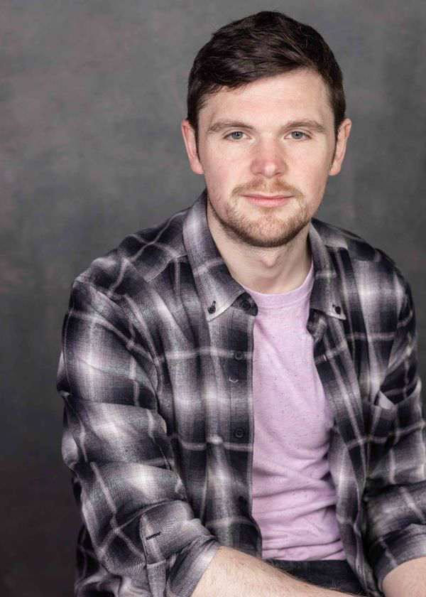 |  | Experience  STAGE:  Sleeping Beauty, Muddles, Outside the Box Productions, Sinead Gibson  The Addams Family, Lucas Beineke, Downham Amateur Dramatics Society, Carrie-Ann Elliott  Beauty and the Beast, Ensemble, Angles Theatre Group, Marie Cunningham  Shrek Rave Events, Shrek, Norrköping, Like It Love It LTD  Dick Whittington, Dick Whittington, Outside the Box Productions  TV:  Call the Midwife, Coal Worker  The Crown, Wedding Guest  FILM:  Goldilocks and the three bears: death and porridge, Mamma Bear, Rees Dragon Productions and Gold Eagle Productions, Craig Rees  Super girl: Titans, Corporal Harry Smith,  Director: Mark Owen  Scoop, Passerby and hand double, The Lighthouse Film and Television, Philip Martin  Broken Path, Jack Raven, Southgate film production, Jamie Pratton  MODELLING:  Morrisons – Autism acceptance week  Zebra Technologies – product promoting – filmed in Utrecht.

Skills
Accents: Scottish, cockney, German, Spanish, French

Music/Dance: trained singer (baritone, bass and tenor), tap dance (intermediate), disco dancer, musical theatre,
Salsa (intermediate)

Other skills: improvisation, impersonation, mime, narration, actor-singer, puppetry-hand, voice acting, sound and light operator

Sports
Swimming, rowing, running, archery, basketball, korfball, Badminton, table tennis, boxing,

Education and Training

- One one one sessions in acting and singing with tutors
- Attended singing and acting workshops
- Audition preparation with Talent Inc

