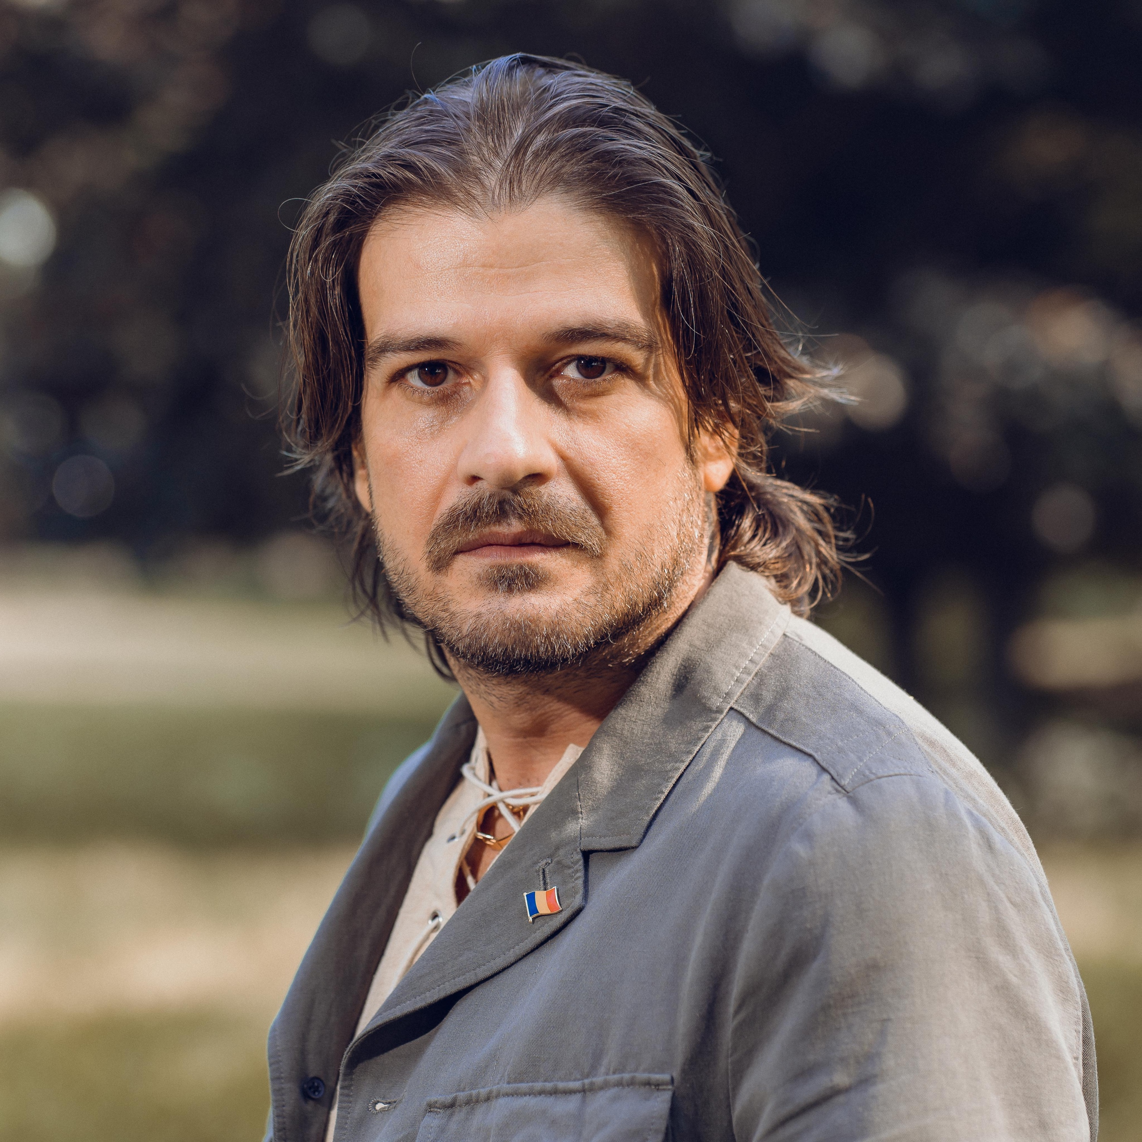**Ioan Romulus Hotea**

romulushotea@yahoo.co.uk

07518512687

APT Parkview, Flat 17, Mezzanine floor, Great West Road, Brentford, Middlesex, TW8 9GR

**Marital Status**: Married

Date of Entry to the UK: 14/02/2009

**WORK EXPERIENCE**

Self employed

**Actor, Writer, Producer – July 2007 - Present**

Company Name – Entertainment Partners

Location: London, England

**1. Stunt Actor in Ruxx – Tv Series - 2022**

**2. Vlad – TV Series – Poker Dealer – 2020**

**3. Triplusec – TV Series – Hipster – 2018**

**4. Iubire si Secrete – TV Series – Marco Negulescu - 2018**

**5. Dangerous Game – Movie - Poker Player – 2017**

**6. Metamorphosis A.D – Movie – Demitruis Cornelius – 2017**

**7. Heists: Stealing the Mona Lisa – TV Documentary –  2017**

**8. Stunt Actor in Justice League – driver - 2017**

**9. Hummingbird- Short Film – Barry – 2016**

**10. Lucky Man – TV Series – Prisoner – 2016**

**11. Stalemate – Short Film – The Banker – 2015**

**12. The Rise of the Krays – Movie – Police officer – 2015**

Responsibilities:

• Responsible for making decisions

• Rehearse and memorise lines

• Research the play/character

• Attend all rehearsals scheduled

• Attend costume fittings

• Take direction from the Director and/or Choreographer

• Work with other Performers

• Attend technical and dress rehearsals

• Acting involves collaborating, and that sometimes means conveying to others details about a scene or a performance.

**Personal skills and values:**

* an understanding of organisational behaviour and structure
* analytical and critical thinking
* creative approach to problem solving
* ability to make decisions using own initiative
* good stage, screen and vocal presence
* the ability to enter into another character and engage with the audience
* having the energy and dedication to perform
* self-reliance, initiative and the ability to manage time, projects and resources
* the benefit of having a good memory
* active listening

**Other skills:**

|  |
| --- |
|  |
| Acrobatics, Aerial Work, Alexander Technique, Ambidextrous, Animal Handling, Artist (Fine Art), Artist (Portrait), Artistic Director, Assistant Director (experienced), Calligraphy, Chainsaw Carver (experienced), Chess, Club Swinging, Contact Juggling, Cow Milking (by hand), Croupier, Devil Stick, Diablo, Director, Drama Workshop Leader, Event Host (experienced), Farm Skills, Fashion Design/Styling (experienced), Filmmaker, Gun Spinning, Hand Modelling, Horse Training, Illusionist, Improvisation, Interior Design (experienced/qualified), Interpreter, Juggling, Life Modelling, Living Statue, Mime, Model-professional, Photographic Model, Poker, Snowmobile/Snowscooter Guide (professional), Story Telling, Survival Skills, Translating, Translator, Workshop Leader (Acting), Writer |
|  |

**EDUCATION**

**Level 3, September 2022– June 2023**

UKCBC, University of West London, Business Studies

Location: Liverpool Street Campus

2023: BRITISH ACTION ACADEMY  
  
Warrior Masterclass Phase III - TITAN, able to choreograph and perform various fight routines with different weapons systems as a principal. 5 characters (spartan/hoplite - spear&shield; thug/hooligan - bare hands&knife; Medieval Knight- long sword (two handed sword) and shield; Pirate - cutlass; Gladiator- gladius&shield  
  
2020:

Acting accents workshop by Mike Savuica- bursary 6 months   
  
2017:  
  
Bursary to the School of Acting by the Director Florin Serban  
  
2016:

Actors Centre- various workshops

Creative Skillset and The Production Guild of Great Britain : Film Production: Behind the screen of Future Filmmaking, London, UK

National Film And Television School and BFI Film Academy : Explore Filmmaking: From Script to screen, London, UK

2015:

Shepperton Studios, London, UK

WarnerBros Studios, London, UK

Pinewood Studios, London, UK

British Action Academy : Warrior Masterclass/Phase II Battle, Surrey, UK

British Action Academy : Warrior MasterClass/Phase I, Surrey, UK

**Links:**

[**https://www.spotlight.com/4056-8943-1300**](https://www.spotlight.com/4056-8943-1300)

[**https://instagram.com/romulus_hotea?igshid=OGQ5ZDc2ODk2ZA==**](https://instagram.com/romulus_hotea?igshid=OGQ5ZDc2ODk2ZA==)

[**https://m.imdb.com/name/nm7118565/?ref_=nmbio_ov**](https://m.imdb.com/name/nm7118565/?ref_=nmbio_ov)

Reference: Scott Jeffrey, [proportionproductions@gmail.com](mailto:proportionproductions@gmail.com)

[scottjeffreyproducer@gmail.com](mailto:scottjeffreyproducer@gmail.com)