Charlotte Moloney Wemaere
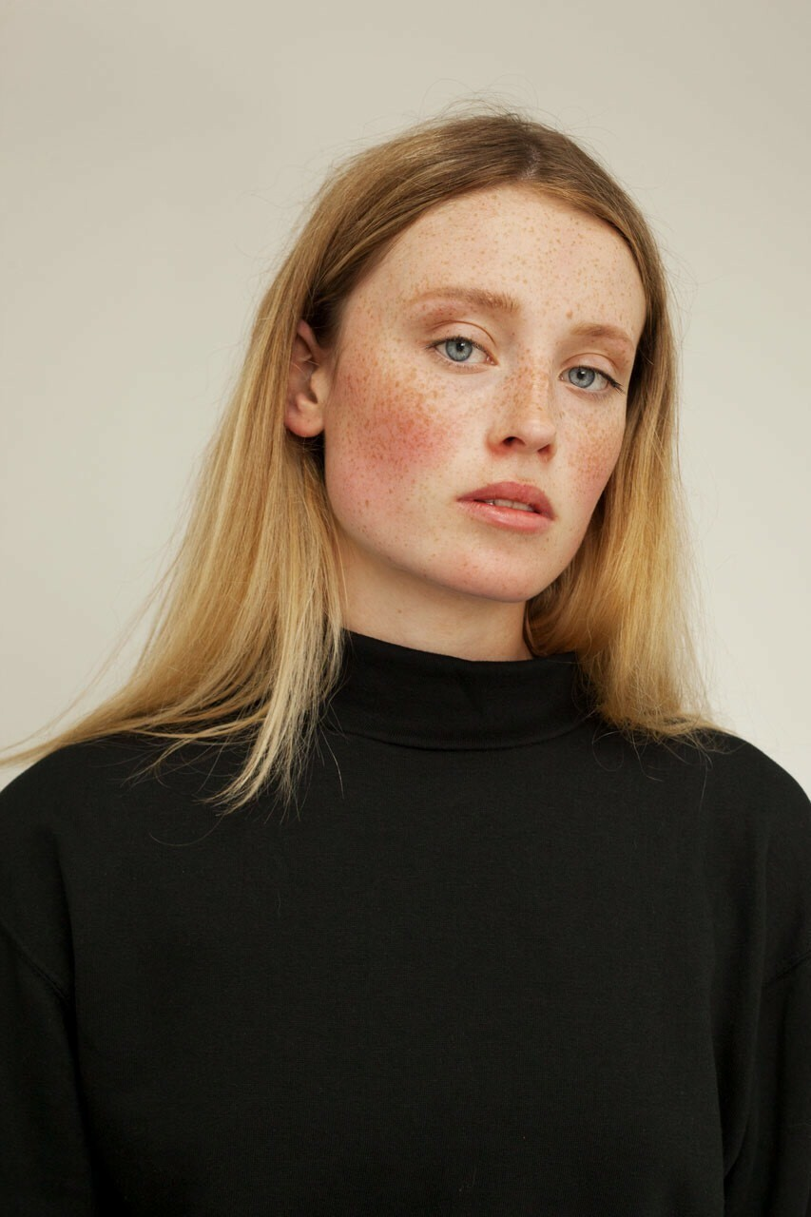

Playing Range: 16-27  Nationality: Irish/French |  | Height: 5’’10  Eyes: blue  Hair: blonde  Frame: slim

Training
Acting for Camera with Noel Brady (2023) |  | Gaiety School of Acting
The Unseen Drama School (2023) |  | The Unseen London
Screen Acting 2 (2023) |  | City Academy London
Lonesome workshops (2023) |  | The Lonesome workshops London
Acting for Camera (2024) |  | Flying turtle productions
Ballet (Grade5), Modern jazz (grade 5) (2008-2017) |  | Bray School of Dance
Action Arts Performing Arts school (2011-2013) |  | Hazel Lowry
Screen experience (TV & Film)
Title | Role | Company | Director
This Isn’t How I Pictured It (unreleased) | Claire ( lead) | NeufCinq Productions/Disamare Productions | Charles Burrough
Soulm8te (unreleased) | Lymfinity girl | Atomic Monster/Blumhouse Productions | Kate Dolan
Power Ballad (unreleased) | Model at Party | 30West | John Carney
Wednesday (unreleased) | Siren Student | Netflix | Tim Burton
Vikings: Valhalla | Local maiden | MGM television | Jeb Stuart
BIFE Grad film: It’s My Body | Lead female | BIFE | Mark Curran
Something Between us Short film | Lead Female | IADT graduate film | Daniel Byrne
Weddings at the Westbury advert | Bride | The Westbury | The Story of Eve
Commercial Work
Company | Date
Krispey Kreme Womens World Cup PR | July 2023
Kildare Village Outlet | October 2021
Brown Thomas 2021 campaign | January 2021
Body & Soul Festival Recycling campaign | May 2022
Allure Bridals/ Wilderly Bridal advert | July 2022
Vogue China Fashion Fund show | September 2024
Tony Ward Couture Show Room PR | September 2024

Skills
Skills: Fluent English/Irish/French, Qualified Veterinary Surgeon, Experienced Model, Experienced Horse rider, boxing, swimming, running, dancing, experienced animal handling
Accents: Irish, English, French, General American
Miscellaneous: Veterinary Medicine degree, Full drivers license

