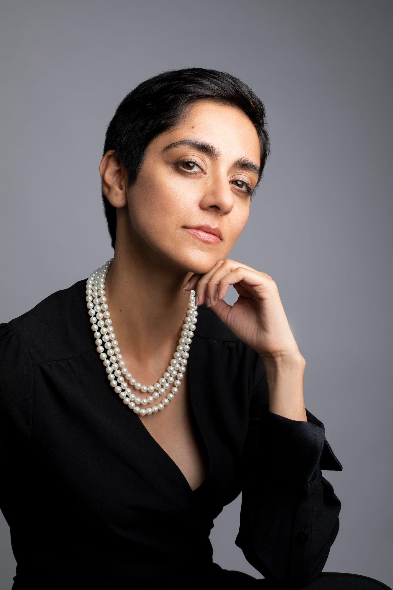

Gwen Hussein (she/her)

WEBSITES & MEMBERSHIPS

Spotlight - 1975-6722-1572

https://www.spotlight.com/1975-6722-1572

https://www.instagram.com/gwenisonscreen/

PROFILE

Born and raised in the UK with stints living in Zambia (3 years) and Pakistan (8 years), my childhood allowed me to explore diverse cultures. My initial education was in IT and Economics, and I worked in Finance & Accounting for 13 years whilst also designing jewellery. I believe this has translated into my acting work, allowing me to portray characters from varying backgrounds.

CAREER SUMMARY

2024

- Bridge - Feature Film: Inspector Purva
- Trauma - Feature Film: Ms Voss
- Grey - Feature Film: Renu
- European Mushrooms - Commercial: Theatre Lady
- Tubi - Commercial: Art Critic
- Dinosaur - Short Film: Matthew’s Mother
- Olympus Medical Solutions - Corporate Film: Support Manager
- Oscar Kilo (NPWS) - Stills: Detective
- Burning Hands - Web Series: Agent Siddiqui
- Redemption - Short Film: Ambassador

2023
- Google - Corporate Training Film - Samira
- Cambridge University Press - Branded Content: Architect
- Medecins Sans Frontieres - Training Film: Marwa
- Wolt - Commercial: Mum
- Santander - Online Commercial: Sophie
- Go Student: Mum
- Accenture - Corporate Film: Tanya
- Blacklane - Branded Content: Chauffeur
- KPMG - Corporate Film: Lead Partner
- Ek Kori Prem Katha (Hindi) - Feature Film: Shafinah
- The Judicial College - Corporate Film: Judge Eleanor
- Athletia - Online Commercial: Voiceover Artist
- The Bryanston - Branded Content: Mum
- Meg 2: The Trench - Feature Film: Hand Double

2022
- De Vere Care - Corporate Animation: Voiceover Artist
- Roche - Corporate Animation: Voiceover Artist
- 175 Park Avenue Investor Video: Model
- PricewaterhouseCoopers - Corporate Stills: Model
- Coventry Building Society - Corporate Stills: Model
- Meg 2: The Trench - Feature Film: Hand Double
- Bridgerton (S2) - Television Series (Netflix) : Maid to Lady Bridgerton
- The Batman - Feature Film : VIP Mourner
- All The Old Knives - Feature Film : Plane Hostage

2021
- Legal Shield - Corporate: Office Worker (featured)
- Heart Radio - Commercial: Office Worker (walk-on)
- Recycle Now Campaign : Hand Model
- Otrivin ( Arabia) - Commercial : Sippy Cup Mum (walk-on)
- Derwent London - Lifestyle Shoot : Model
2020
- Mad About Specs - Online Ad : Freelancer On Laptop
- Ladbrokes TVC : Train Passenger
2019
- McDonald's - Social Media Shoot : Hand Model
- OnePlus Video Tutorial : Hand Model
2018
- Formula E - Brochure : Model
- Brexit: The Uncivil War - Feature Film : Hand Double

TRAINING

Acting The Unseen (2023)

Voice-over training workshop: Sugarpod Productions (2019)

ISEB Foundation Certificate: Business Analysis (2009)
Middlesex University- BSc (Hons): Business Information Systems & Management (2004)
London School of Economics
(Overseas programme)- Diploma: Economics (2002)
A Level: Law, Management of Business & Economics (2000)

