**Andrew Wallis, MBE, OL, DL**

Actor, Voice-over Artist, Presenter and Lecturer

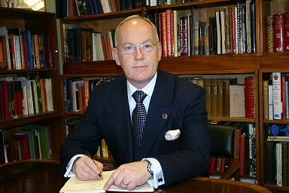

**Background**

Andrew spent the first 32 years of his business life in investment banking rising to become a Global Director of **Deutsche Bank**. He stepped away from banking in 2005 to take over running **The Guards Museum** near Buckingham Palace a post which he held for a further 18 years retiring from the museum in October 2023.

**Performance**

His training in the bank and his role in the museum dictated that he was required to ‘perform’ in front of large groups of people – which he found to be both challenging and exhilarating. In the bank he lectured on a variety of subjects across Europe such as Change Management and Outsourcing of Services. At the museum, he lectured on the history of The Guards, the Royal Family and Rudyard Kipling. His outreach work meant that he became a regular lecturer on **Cunard’s Cruise Liners** (Queen Mary II, Queen Victoria and Queen Elizabeth). During the pandemic Andrew also created 26 episodes of his own podcast **Bearskins, Bayonets and Bravery – Tales from The Guards Museum** and also developed quite a following on **Tik Tok** with a series of short videos about interesting objects in the collection – look for Guards_museum.

Latterly, he has been accredited as a VIP tour host at **The Churchill War Rooms** where he channels his inner ‘Winston’ to regale visitors with tales and anecdotes about this iconic statesman and his wartime ‘bunker’.

Andrew has also resurrected his musical skills and sings in a Sea Shanty Band, **Sloop Groggy Dogs** in which he also plays penny whistle, ukulele, concertina and a variety of percussion instruments at venues and festivals across the UK.

**Training**

Andrew has recently undergone acting training with the **London Actors Workshop** and voice-over training at **The Showreel** where he acquitted himself with some style.

**Availability**

Andrew is willing to consider any meaningful roles but particularly enjoys bringing his significant knowledge of military matters to enhance roles relating to that subject.