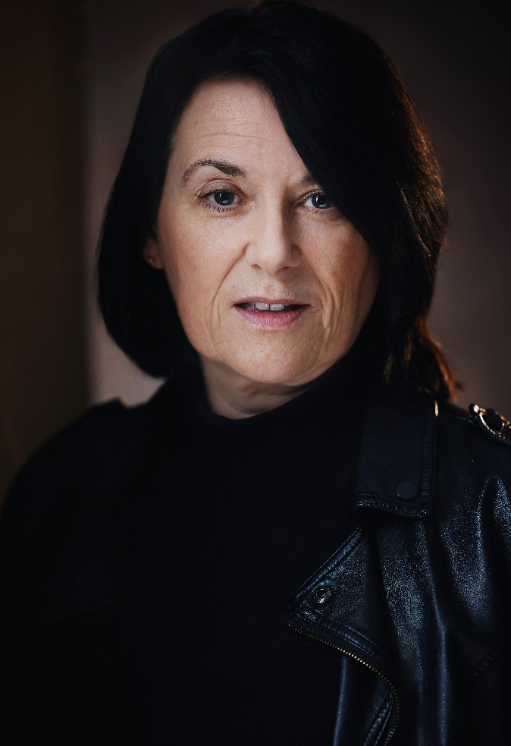 |  | Sara willats  Actor and model
Profile  I am a confident and reliable London based actress with 4 years experience in TV, film, modelling and video.  Contact  PHONE:  07984 418550  EMAIL:  Saraw441@outlook.com  spotlight pin  9217-3496-3962  skills  Fluent in French and Spanish  Can cry on cue  Professional, hard working and passionate.  Clean car license and own car |  | 2024 upcoming  Roles in 1 Romantic thriller short and 3 student films booked  Politician in Ecosia marketing campaign  Corporate model for Caia library images  Grace Season 4, ITV - Passerby with car  A Killer Makes a Call, Channel 5 - Dawn Lewis  Masked Singer, ITV – stunt performer (Eiffel Tower)  Big Mood channel 4 – feature in one episode  Investor in HSBC modeling campaign  Expereo One - Corporate video  2023  Nirahua Hindustani 4 feature film – Jack’s mum  Behind the Door, Metschool film – Tilly (lead)  Au Revoir Gladys, student film – Romy (lead)  Memories student film – Mum  Darko Student film – Mrs Piper  Unsettled student film - Pauline  G Choppa rap video – Dancing Granny  2022  Silo, Apple TV – Stand in for Angela Yeoh  Holby City, BBC1 – body double with prosthetics for Jenny Howe  Hinterview Ltd, Corporate video – Ellie Palmer  97 Minutes feature film – featured hostage  Funeral student film – Greek  I’m Not Being Melodramatic student film – Nurse Maria

