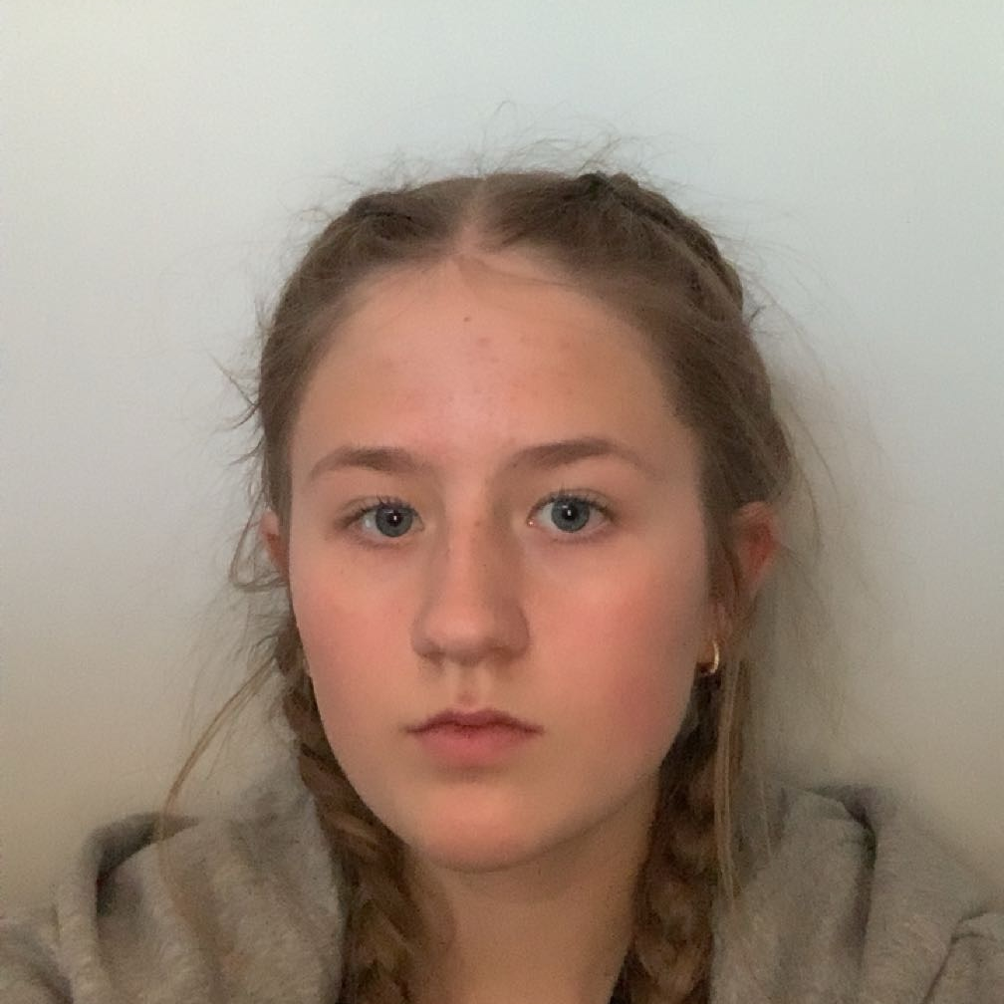
Personal Information

(Non-Union)

+354 868 0710
margretblondahlm@gmail.com

Height: 5’7 (170cm)
Weight: 138 ibs (63 kg)
Eye Color: Blue
Hair Color: Blonde

____________________________________________________________________________________

THEATER

Christmas play. Wise man School play. ‘20

____________________________________________________________________________________

FILM/TV

Presentation of Barnahús Lead Amopix studios ‘23

____________________________________________________________________________________

SPECIAL SKILLS
Fluent in Icelandic, advanced in mountain biking, advanced in snowboarding, horse riding, skiing, swimming, drive(do not have a license), jump on a bike, knitting, baking/cooking

