Amber Jeanette Zarevich

62 Anson Road, London NW2 6AD ● Phone: +44 7770 789599 ● Email: ajzarevich00@gmail.com

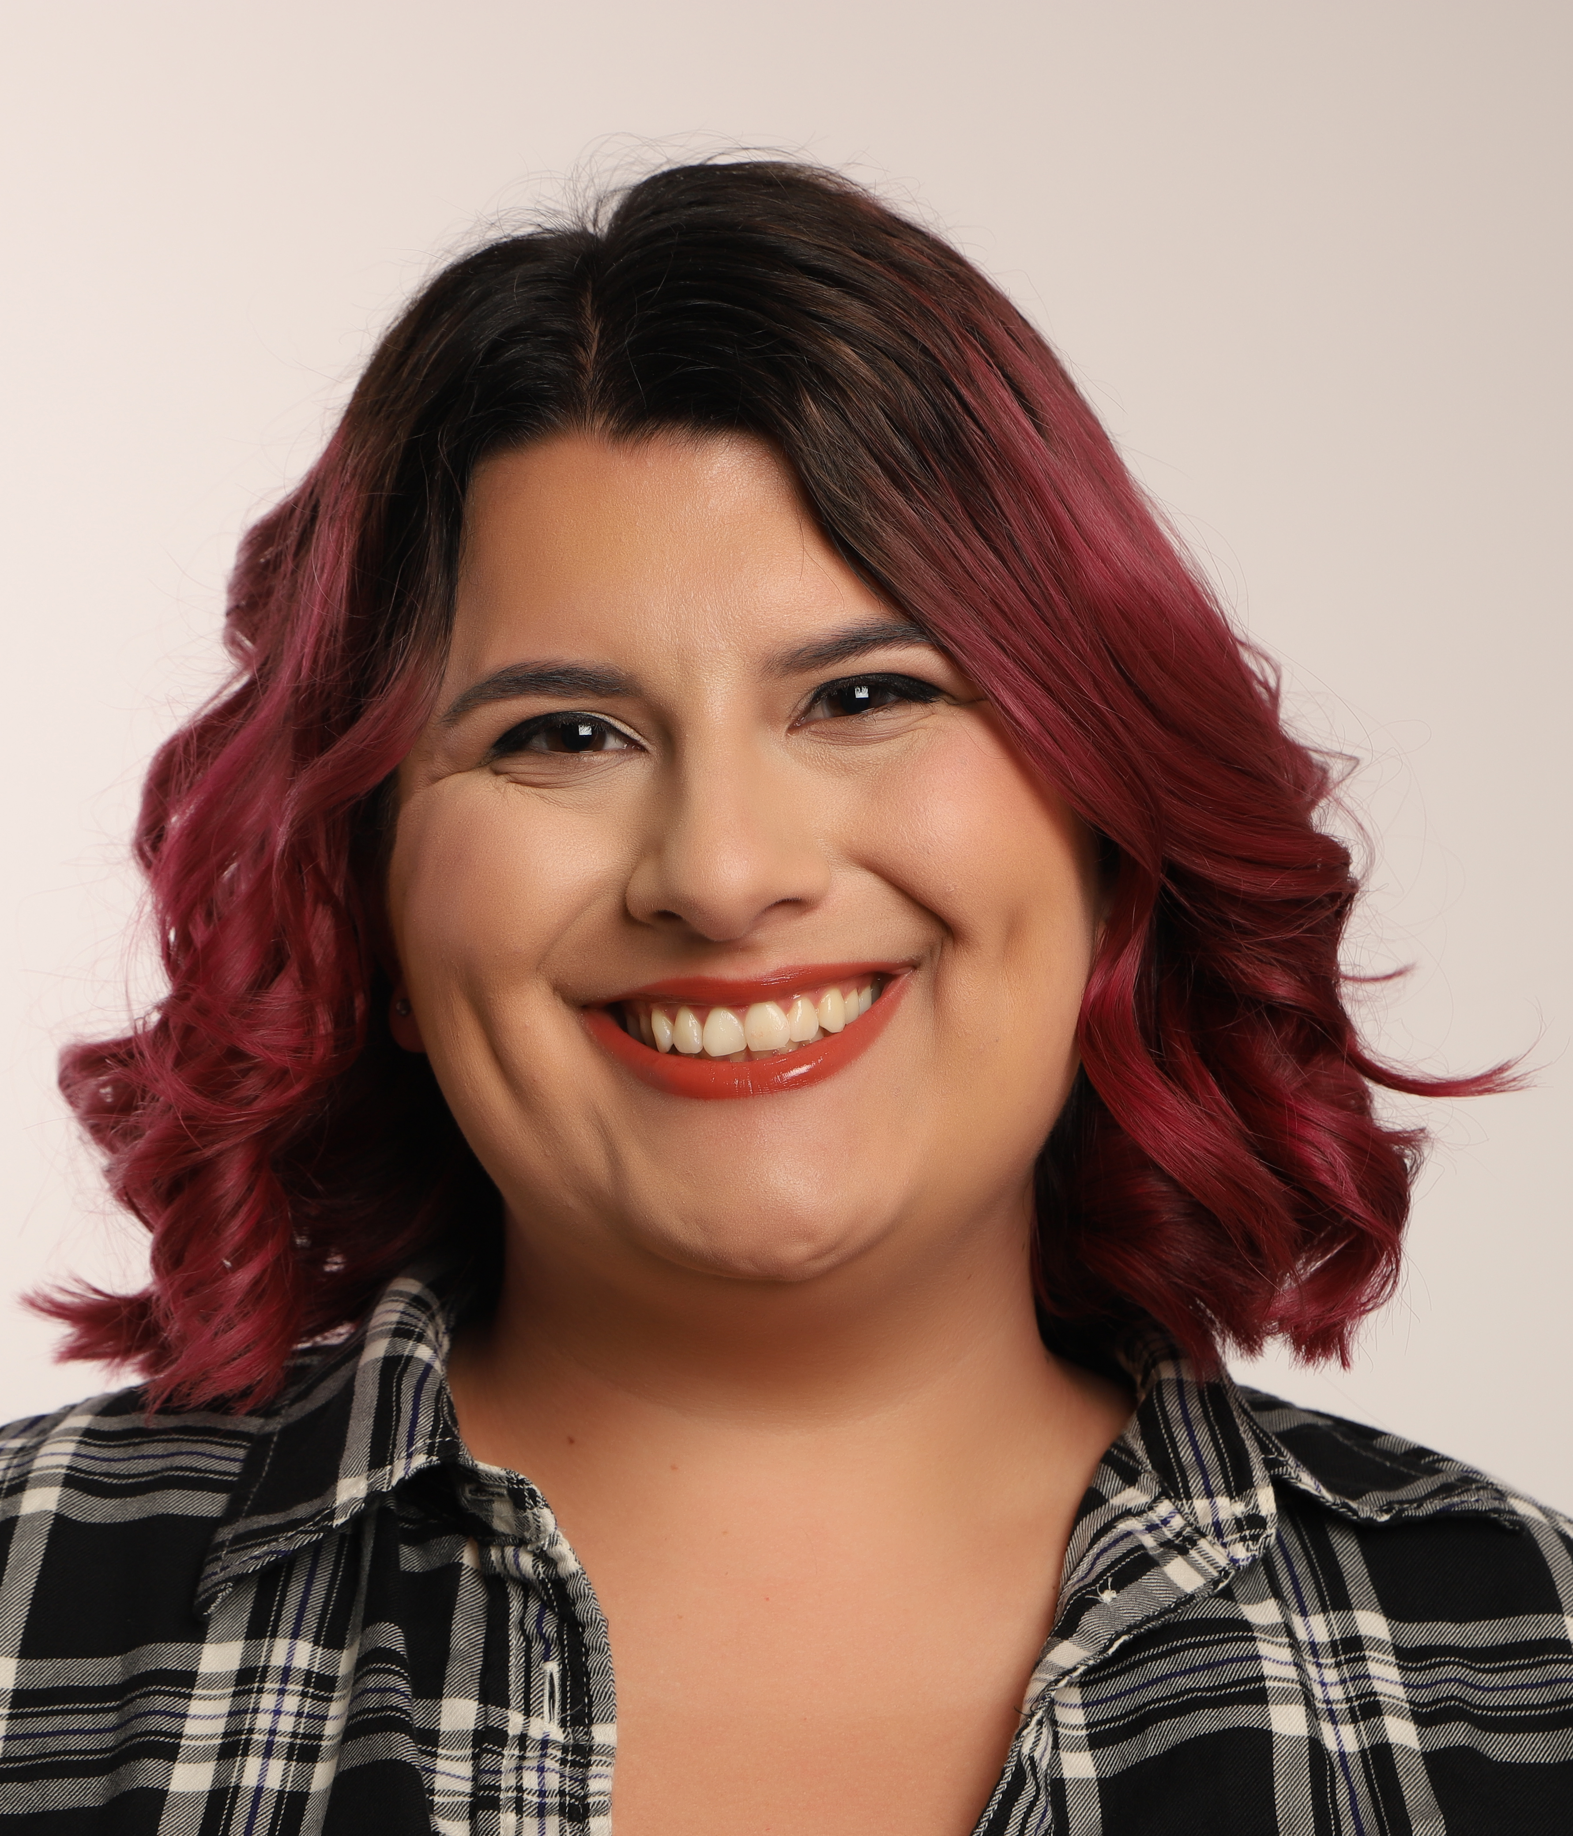
Height: 5 ft 7 in  Weight: 240lbs  Hair: Dark Brown  Eyes: Brown  Build: Curvy  Age: 23  Role playing ages: 19 - 29  Location: London  Nationality: American  U.S. Passport | Accents: Standard American, RP, American Southern, Russian  Languages: English (native), Spanish (proficient)  Singing: Musical theatre, Pop, Country  Sports: Archery  Screen Skills: Motion Capture, basic firearms
Screen
film

Past Tenants (2023) | Lucy Bimor | University of Chichester
Killing Innocence Scene (2022) | Tomi | University of Chichester
Student Short Film (2021) | Haley | University of California, Davis
Finding Nemo Monologue (2019 | Dory | American Academy of Dramatic Arts
Short Scene (2019) | Roxy | American Academy of Dramatic Arts
Theatre
Wicked Monologue (2019) | Elphaba | University of California Davis

training | 2022-2023 | MA Screen Acting, University of Chichester
 | 2020-2021 | Camera Acting, Clay Banks Studio International, Los Angeles
 | 2018-2021 | BA Theatre and Dance, University of California Davis
 | 2020 | Camera Acting (Single Cam), Brian Scolaro, Zoom
 | 2019 | Training Certification, American Academy of Dramatic Arts
Skills | Script Analysis
 | Memorization
 | Character Development
 | Stagecraft and Management

