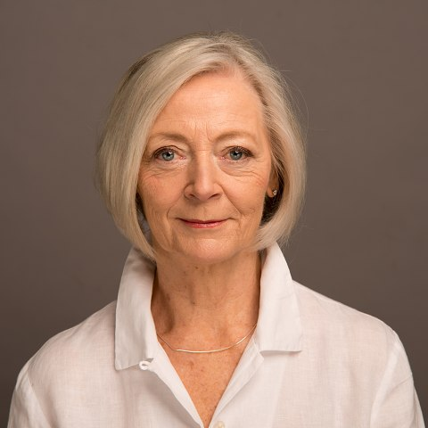
Sara Wilson-Soppitt
07973 963406
sjwilsonsoppitt@gmail.com

Represented by Kelly Morgan at DubsInternational
https://www.spotlight.com/0850-6722-7192
Playing age: 60-70
Height: 5’4”
Appearance: Caucasian
Location: South East

Achievements: Best Actress in 2023 Berlin Short Film Festival for iCare

Voice quality: Warm and clear

Film – 2022-2023
Protect Yourself Online Christine Portsmouth University
Lady with an Amazon Anamaria London Film School
iCare Lonely lady Escape Studios
The Great Method Yvonne Da Silva
Evanescent Nexus Mother De Young

Amateur roles 2015-2023
Production Role Group/society
Blithe Spirit Madam Arcati Bourne Players
The Militants Lilian Malin Bourne Players
Lord Arthur Savile’s Crime Lady Julia Merton Grayshott Stagers
The Browning Version Millie Crocker-Harris Tilbourne Players
Quartet Jean Horton Grayshott Stagers
The Importance of Being Earnest Miss Prism Tilbourne Players
May Way for Lucia Elizabeth Mapp Tilbourne Players
The Cemetary Club Ida Tilbourne Players
Witness for the Prosecution Myers Tilbourne Players
The Crucible Rebecca Nurse Tilbourne Players
Still Life Myrtle Bagot Frensham Players
Present Laughter Monica Reed Tilbourne Players
The Heiress Lavinia Penniman Tilbourne Players

Skills
Accents: RP, London, Scots, Northern UK, American, French, Italian
Competent soprano

Training
Guildhall Summer School in Acting
Voice-over training with Gary Terzza

