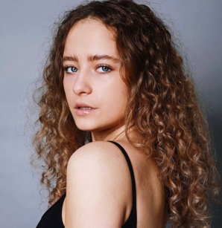
Izabel bartholomew
Playing age 16- 24
Highte – 5ft 5
Hair colour – blondy/ brown
Hair leng- long
Eyes – blue / green
Bulid- slim
south west London
07504111797
Isabelbartholomew0@gmail.com
https://izabelbartholomew.modelprofiles.co.uk
Training
Kindom School Of Arts for 2 years and I’m re joining after covid in April 2023
London Actors Workshop 29th January- 16th April
British Action Academy Warrior Phase 1
Kaos Atlanta Dance Intensive
Monsters Dance Intensive Los Angles
Horse riding Advanced- Professional

Education

West Thames college, UAL level 3 dance,, Isleworth, london, 2019

Kingston upon Thames college, HND PERFORMING ARTS,

Madame Tussauds photo shoot with tinker bell- 2006
Sky Sports advert- 2019
Vinesto Music Video x2 – 2021
Ocean Tisdall music video -2022
H&M advert for New Year- 2022
Advert for climate change-2021
Princes Trust and Cadbury- 2022
LUXE Fashion NYC – 2022
Documentary on a dancer GIANT logos -2022
London Film School Short Film – 2023
Bibigo Commercial- 2023 Thailand

