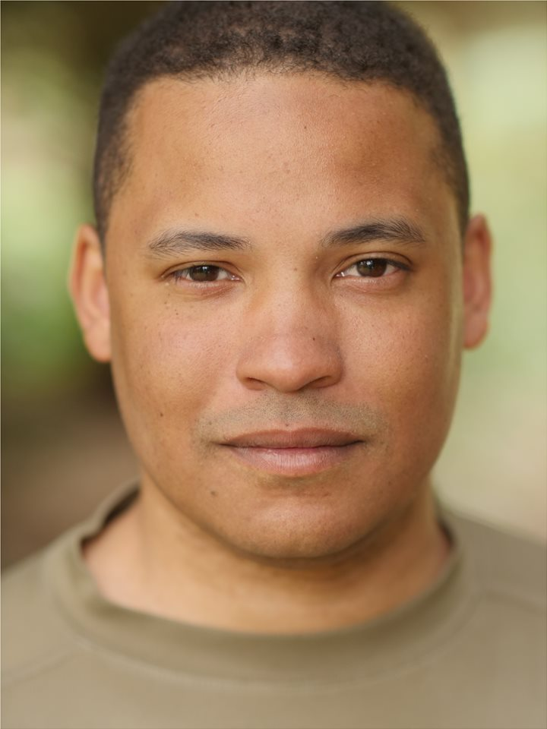 |  | Characteristics
Ethnicity: | Mixed Race | Build: | Average
Age Range: | 20 - 30 | Gender: | Male (he/him)
Height: | 178cm (5’10’’) | Chest: | 42/44 inch
Weight | 90 kg | Hips | 36 inch
Hair Colour: | Black | Inside Leg: | 32 inch
Eye Colour: | Brown | Shoe Size: | 10

Lee-Anthony Wallis  Profile  Born 4th January 1989.  Profession Actor since 2008. Born in Birmingham, UK. Currently living in Hagley, UK.  Full Clean Driving License: B, C and D1  CONTACT  PHONE:  07983515322  SPOTLIGHT PIN:  9974-4502-9220  EMAIL:  Lawallis@live.co.uk  AGENT:  AP Talent Managment  Pip Cofton  https://www.aptalentmanagement.co.uk  info@aptalentmanagement.co.uk  +44 7572251357 |  | Credits…
Flat share (TV): Stand in – Anthony Walsh, 2022, Paramount Pictures, (Dir) Chloe Wicks

The Moment of Proof (TV) – Reconstruction Actor, 2022, BBC/Brown Bob Productions, (Dir) Alex Levitschi

One Night with Marilyn (Stage) – Orderly Fletcher, 2022, KSW Network,
(Dir) Laura Liptrot and Dina Del Forno

BBC Doctors (TV): PC Danny Wark, 2017, BBC, (Dir) Pier Wilkie

Tommy’s Passchendaele (Stage): Captain (lead): 2017, ARMY West Midlands, (Dir) Major Roy Fitter.

Bicycle Commercial (Internet): Myself (Presenter): 2016, Halfords (internet), (Dir) Neil Phillips

 |  | EDUCATION
Bachelor of arts (BA HONS) in DRAma and performance
university of worcester: 2007—2010
ARMY RESEVRE SOLDIER: 2014 - Current
WEAPONS & FIREARMS TRAINED
ECSPC FOUNDATION FIGHTING AWARD - SCREEN COMBAT
STAGE COMBAT TRAINED
Highly skilled: Cricket, Skiing, Football, Basketball, Swimming, Golf, Badminton, Tennis, Table Tennis.

