1. **NIGEL MERCIER**

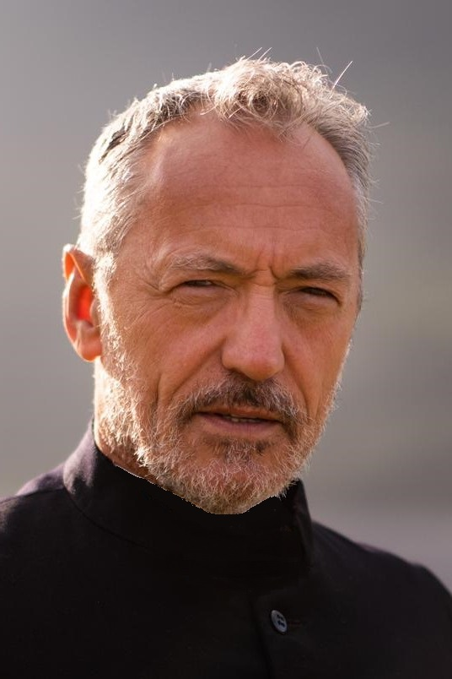

**NATIONALITY** **Irish**

**CONTACT** **+353(0)87-765-9634**

[nigel.mercier@gmail.com](mailto:nigel.mercier@gmail.com)

**PLAYING AGE** 55-65

**WT** **12 stone**

**HT** **5’9”**

**HAIR** **Grey**

**EYES** **Brown**

Shape

AWARDS: Best Actor of the festival ALTFF Toronto June ‘22

Best Acting (honourable mention) London International Monthly Film Festival. July ‘22

Numerous nominations

## **CREDITS**

|  |  |  |  |  |  |
| --- | --- | --- | --- | --- | --- |
| **Year** | **Type** | **Role** | **Company** | **Production name** | **Director** |
| 2022 | Commercial | Lead | Ad Vantage | Fairco | John Gleeson |
| 2022 | Short Film | Fr Ryan | Dolmen Film | The Cathedral | Turlough O'Cinnéide |
| 2021 | Television | Sal O'Malley | Kiyo prod | Groundbreaking | Patrick William Smith |
| 2021 | Television | ERU Commander, John | RTE/Saffron Moon | Hidden Assets | Thaddeus O'Sullivan |
| 2021 | Television | DI Steve Yates | RTE | Fair City | Various |
| 2020 | Television | Ned Hutchins | BBC/Treasure Entertainment | Smother | Daithí Keane |
| 2020 | Television | DI Steve Yates | RTE | Fair City | Various |
| 2019 | Television | DI Steve Yates | RTE | Fair City | Various |
| 2018 | Television | HMSU Commander | Hat Trick / JM Prod | Bloodlands | Pete Travis |
| 2018 | Feature Film | Dr Gerrick | Babyjane Prod | The Martini Shot | Stephen Wallis |
| 2018 | Feature Film | The man | Greenflash Pictures | Night Shift | Stephen Hall |
| 2018 | Television | DI Steve Yates | RTE | Fair City | Various |
| 2017 | Feature Film | Rodney | Picture Perfect | Hexing | Christophe Lenoir |
| 2017 | Television | Essam Eid | TFPTK Films | Assassins | Keith Farrell |